**Live Video Streaming (Android)**

**Under the guidance of**

**Shrinivas Dudhani.**

**Index**

# Table of Contents

1. Problem definition

2. Project Scope

3. Architecture

4. Coding standards

5. Software Development Life Cycle (SDLC)

6. Waterfall Model

7. Feasibility Study

* 1. Technical Feasibility
  2. Economical Feasibility

7.3 Operational Feasibility

8. Data Flow Diagram

8.1 Level 0

8.2 Level 1.1

8.3 Level 1.2

8.4 Level 1.3

8.5 Level 1.4

8.6 Level 2.1

8.7 Level 2.2

9. Quality Assurance

10. Software and Hardware Requirements

11. Team Members

**Live Video Streaming**

**(Android)**

Stream live video using a mobile camera to a distant /remote computer and view the same on the web browser.

**1. Problem Definition:**

Current solutions, first streams the video to the server and save the same. It is then broadcasted to the client’s browser. This type of streaming is not live (i.e. stored and then broadcasted).

**2. Project Scope:**

This project allows a real-time video streaming service from an Android mobile device’s camera to a server. The real-time video can then be viewed from a web browser on the client’s computer. The project builds on open source code and open protocols to implement a set of software components that successfully stream live video using NanoHTTPD.

NanoHTTPD is an open-source, small-footprint web server that is suitable for embedded applications, written in the Java 1.1 programming language.

Users will have the ability to broadcast news and events live, using only an Android based mobile devices and an internet connection via the cellular network or Wi-Fi.

All these phases are cascaded to each other so that the next phase is started as and when a defined set of goals are achieved for first phase and it is signed off. Hence the peculiar name. All the methods and processes undertaken in the model are more visible.

**3. Architecture:**

The following figure presents architecture overview of the project. When Application on in Android phone ,It shows the start button ,when we click on the start button, the Application starts the capturing frames, which is in the format of YUV, then it convert it into the RGB format and finally we stores in the JPG format.

The stored frames we forward it to the web browser(client) by using the NanoHTTPD web server.

**Web**

**Browser**

**Android Mobile Camera**

**Frames**

**NanoHTTPD**

**Web Server**

**Figure 1: Architecture Diagram**

**Android Mobile Device:**

Android is a recently developed operating system designed for mobile devices. It was developed by Google and uses a Linux based kernel, Java compatible libraries along with the just-in-time compiler for development in the Java programming language. It supports many hardware components. Common hardware consists of cameras, a Wi-Fi communications chip, Bluetooth sender and receiver and a color touch screen. The Android Application Program Interface (API) contains many functions and classes to control the cellular devices. This functionality is all available in a single device with at least a day worth battery life.

In our project we use platform Android 2.2.

**NanoHTTPD:**

A free, simple, tiny (1 java file), nicely embeddable HTTP server in Java.

NanoHTTPD is an open-source, small-footprint web server that is suitable for embedded applications, written in the Java 1.1 programming language. The source code consists of a single *.java* file. It can be used as a library component in developing other software (such as measurement, science and databaseapplications) or as a standalone ad-hoc style HTTP daemon for serving files. Due to independence from Java features beyond JDK 1.1, NanoHTTPD is suited for embedded application development, and has been used to build, for example, Android software.

The original version, released in 2003, only included simple HTTP 1.0 features, but the software has been since forked and extended to support some more advanced techniques such as HTML5 video streaming or HTTP uploading through multipart extensions.

**Ways to use:**

* Run as a standalone app (serves files from current directory and shows requests)
* Subclass serve() and embed to your own program Call serve File() from serve() with your own base directory
* To test file uploading, try browsing file-upload-test.htm through NanoHTTPD, upload something and watch the console output

**Features and Limitations of NanoHTTPD:**

* Only one Java file
* Java 1.1 compatible
* Released as open source, Modified BSD license
* No fixed config files, logging, authorization etc. (Implement by yourself if you need them.)
* Supports parameter parsing of GET and POST methods (+ rudimentary PUT support in 1.25)
* Parameter names must be unique. (Adding support to multiple instance of a parameter is not difficult, but would make the interface a bit more cumbersome to use.)
* Supports both dynamic content and file serving
* Supports file upload (since version 1.2, 2010)
* Never caches anything
* Doesn't limit bandwidth, request time or simultaneous connections
* Default code serves files and shows all HTTP parameters and headers
* File server supports directory listing, index.html and index.htm
* File server supports partial content (streaming)
* File server supports E Tags
* File server does the 301 redirection trick for directories without /
* File server supports simple skipping for files (continue download)
* File server serves also very long files without memory overhead
* Contains a built-in list of most common mime types
* All header names are converted lowercase so they don't vary between browsers/clients

**4. Coding Standards:**

General coding standards pertain to how the developer writes code.

General Software Coding Standards and Guidelines:

1. Inline Comments

Inline comments are used to explain the functioning of the task.

1. Naming Convention

a. Classes

Names of classes must start with Capital Letter. They should follow Upper Camel Case.

b. Methods

Methods should be in Lower Camel Case; that is, with the first letter lowercase and the first letters of subsequent words in uppercase.

c. Variables

Variable names should be short yet meaningful. They should follow Lower Camel Case.

d. Constants

Names should be in uppercase.

**5. Software Development Life Cycle:**

A software development process, also known as a software development life cycle (SDLC), is a structure imposed on the [development of a software product](http://en.wikipedia.org/wiki/Software_development). There are several [models](http://en.wikipedia.org/wiki/Software_development_process#Software_development_models) for such structures, each describing approaches to a variety of [tasks or activities](http://en.wikipedia.org/wiki/Phases_of_the_software_development_cycle) that take place during the development process.

**6. Waterfall Model:**

This project follows 'The Waterfall Model' for the SDLC. In this approach, the whole process of software development is divided into separate phases. These phases are:

1. Requirement specifications phase
2. Software design
3. Implementation
4. Testing and maintenance

All these phases are cascaded to each other so that the next phase is started as and when a defined set of goals are achieved for first phase and it is signed off. Hence the peculiar name. All the methods and processes undertaken in the model are more visible.

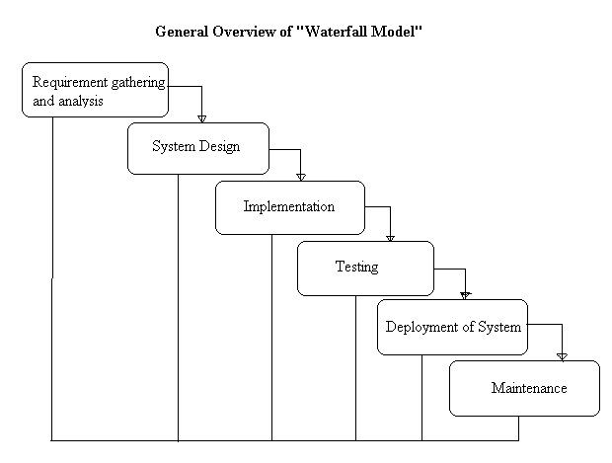

**Fig-1-Waterfall model**

**Reasons to follow this Approach:**

The project requirements are very well known, clear and are fixed. There are no ambiguous requirements. Similarly, the technology is going to be used is also known. As every phase is fixed, there is no need of revisiting.

**7. Feasibility Study:**

The final step of initial investigation of system is the feasibility study. It is carried out to

check the workability of the candidate system. It’s impact on the organizational ability to

meet user needs and effective use of the system. Feasibility is the testing of the proposed

system according to its workability.

A feasibility study is carried out to select the best system that meets all performance

requirements. The result of feasibility study is a formal proposal. This is simply a report-

a formal document detailing the nature and scope of the proposed solution. The proposal

summarizes what is known and what is going to be done.

There are three key consideration involved in the feasibility analysis:

• Technical Feasibility.

• Economical Feasibility.

• Operational Feasibility.

**Technical Feasibility:**

The technical feasibility study compares the level of technology available in the  software development firm and the level of technology required for the development of   the product. Here the level of technology consists of the programming   language, the hardware resources, software recourses.

**Our technical feasibility parameters involves:**

* Do we have the right technical inputs / clarity of this project?
* Do we have the right technical skills to take up this project?
* Do we have the right tools to take up this project?
* Is there any training required / technical mentoring?
* Do we have the right understanding of the concept and deliverable that the

customer desires to have?

* Did we analyze the right way to do this project?

An Androidmobile device combined with its camera and internet capabilities is used to stream real-time video to a web page. It accomplishes the streaming using various open source projects and open protocols. Using standardized and open protocols increases compatibility among clients and results in far more support than less popular or closed protocols.

The open source protocols used in this project is **Real Time Streaming Protocol (RTSP).** The RTSP is a network control [protocol](http://en.wikipedia.org/wiki/Communications_protocol) designed for use in entertainment and communications systems to control [streaming media](http://en.wikipedia.org/wiki/Streaming_media) [servers](http://en.wikipedia.org/wiki/Web_server). This protocol is used for establishing and controlling media sessions between end points. RTSP defines control sequences useful in controlling multimedia playback.

**Web Browser** embedded with **Flash player** plug-in is required to view videos on client’s browser.

**Android Development Tools (ADT)** :It is a plug-in for the Eclipse IDE that is designed to give you a powerful, integrated environment to build Android applications. Developing in Eclipse with ADT is required and is the better way to get started. ADT extends the capabilities of Eclipse viz: to let you quickly set up new Android projects, create an application UI.

**Eclipse (Helios):** Its free a software tool, **open implementation.** It’s release also features new [Linux tools](http://www.eclipse.org/linuxtools/) and JavaScript tools.

**Economical Feasibility:**

Economic analysis is the most frequently used method for evaluating the effectiveness of a new system or project benefit of the proposed system. More commonly known as [cost/benefit analysis](http://en.wikipedia.org/wiki/Cost-benefit_analysis), the procedure is to determine the benefits and savings that are expected from a candidate system and compare them with costs.

Return on investment is also important. [Analysis](http://www.businessdictionary.com/definition/analysis.html) of a [project's](http://www.businessdictionary.com/definition/project.html) [costs](http://www.businessdictionary.com/definition/costs.html) and [revenues](http://www.businessdictionary.com/definition/revenue.html) in an effort to determine whether or not it is logical and possible to complete. The objective of the economic feasibility is to develop a financial model of the business venture. The product of this step is a complete integration of the technical product information and the market study into one or more break-even financial models.

The estimated cost usually considers the whole cost of ownership which includes:

1. Ongoing support

2. Maintenance cost

3. Acquisition cost

In this project, financial requirements are very low, required things are:

1. Eclipse **(**Helios): It is a free software tool.

2.Android Development Tools (ADT): It helps us to develop mobile applications on the Android platform. It is a plug-in for the Eclipse IDE that is designed to give you a powerful, integrated environment to build android applications. It is also a free tool.

3. Android based mobile device with a built in camera.

4. NanoHTTPD web server.

**Operational Feasibility:**

Operational feasibility is a measure of how well a proposed system solves the problems, takes advantage of the opportunities identified during scope definition and how it satisfies the requirements identified in the requirements analysis phase of system development.

The willingness and ability of management, employees, customers and suppliers to operate and support a proposed system. Operational feasibility depends on several vital issues. For example, consider the following questions:  
  
1. Does management support the project?

2. Do customers support the project?

3. Do users see the need for change?

Operational feasibility is mainly concerned with issues like whether the system will be used if it is developed and implemented. A system that has operational feasibility is the one that will be used effectively after it has been developed. The proposed system works effectively on different Android mobile devices. Analyzes the inside operations on how a deemed process will work, be implemented, and dealing with change resistance and acceptance.

**8. Data Flow Diagrams(D.F.D.):**

**Level 0:**

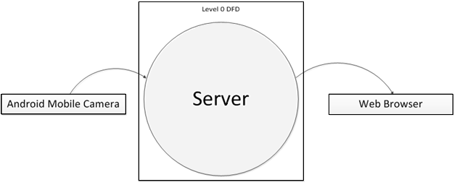

**Level 1.1:**

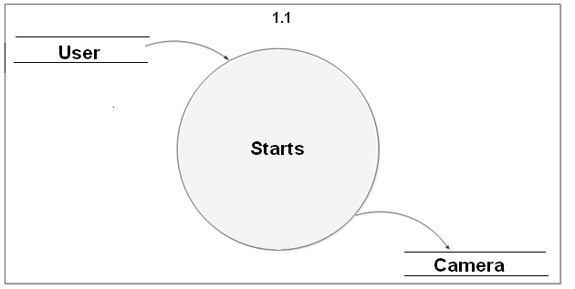

**Level 1.2:**

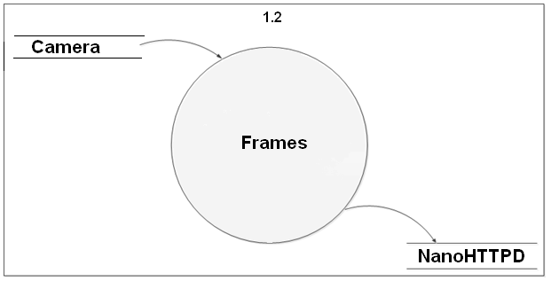

**Level 1.3:**

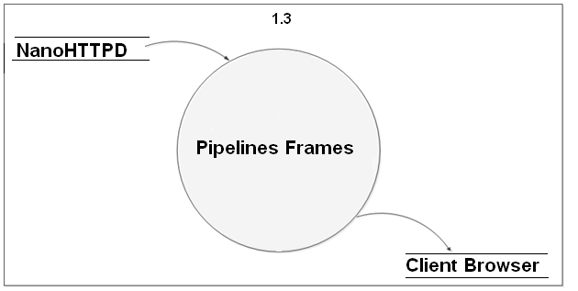

**Level 1.4:**

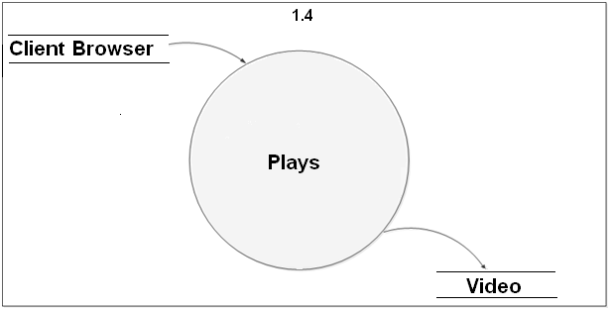

**Level 2.1:**

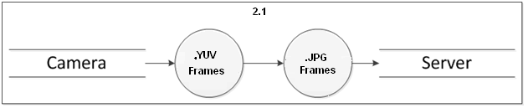

**Level 2.2:**

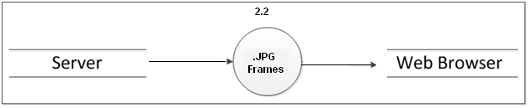

# 9. Use of Quality Assurance Practices:

Quality Assurance is a broad practice used for assuring the quality of products or services. Quality Assurance makes sure the project will be completed based on the specifications, standards and functionality requirement without defects and possible problems.

It monitors and tries to improve the development process from the beginning of the project.

Quality assurance function of an organization uses a number of tools for enhancing the quality practices. These tools vary from simple techniques to sophisticated software systems. To achieve better quality we are using Google SVN(subversion) .

**10. Software and Hardware Requirements:**

**Software:**

* Eclipse (Helios)
* ADT plug-in(Android Development Tools)
* Android SDK
* Web Browser

**Hardware**:

* Android based mobile with embedded camera.
* An implementation of NanoHTTPD Web server in order to transfer the frames to viewing clients.
* 500 kilobyte space on Android mobile phone.

.

**11. Team Members:**

* 1. Akshay Velhal.
  2. Yashwant Patel.
  3. Chetan Paunikar.
  4. Pritesh Jadhav.
  5. Vivek Saxsena.
  6. Prashant Varpe.
  7. Pranali Deshpande.
  8. Sonali Dhome.
  9. Gauri Tembare.
  10. Pradnya Bagave